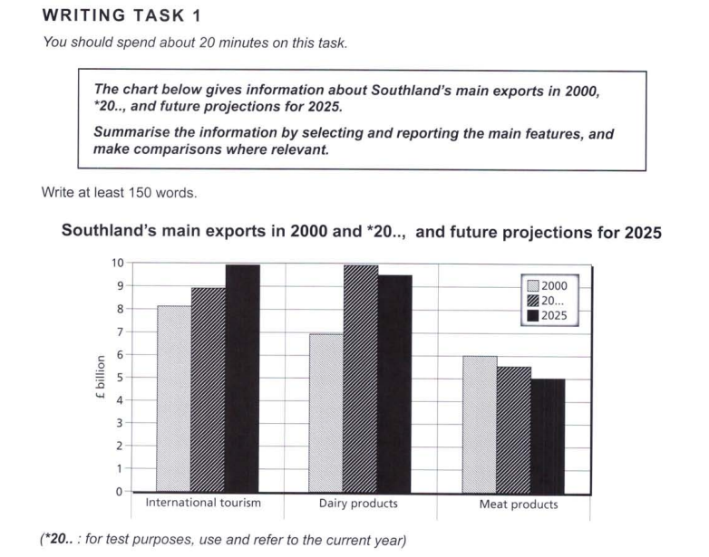

Essay Response:

The bar chart shown depicts the volume of exports (in billions of pounds/GBP) from the region of Southland, highlighting the revenue gained in 2000 and 2023, with projections made for that of 2025. The main exports are international tourism, dairy products, and meat products, each displaying different trends.

Firstly, we can observe that international tourism has been projected to increase its revenues by 1 billion GBP in the next two years, which is also the amount it climbed in the last 23 years. This signals a boost in growth for the tourism industry that would potentially yield gains with exponential growth.

Secondly, although the money earned from dairy exports increased from 7 billion GBP to 10 billion GBP since 2000, these figures are expected to decline by 2025, as could be seen in the chart’s fluctuating values.

Finally, meat products, whose exports have decreased by less than a billion GBP in their value in the past 23 years, are expected to continue this trend, albeit faster, considering that the expected drop in the next 2 years is projected to be the same as the overall decrease in the last 23.

Hence, there is no clear pattern that is common to all of the exports; tourism is on the rise, dairy exports have a fluctuating pattern, and meat products are projected to earn lesser in coming years.